Industry Project
On
Income Insight
Decision Intelligence Platform
AI-Powered Income Prediction & Financial Risk Assessment System
G08
Developed By: - | Guided By:-
Om Gajjar (23162172002)  Nimesh Ghadhvi (22162121004)  Shivam Brahmbhatt (23162582012) | Prof. Dhaval Sathawara (Internal)  Mr. Anoj Dixit (External)

Submitted to
Faculty of Engineering and Technology
Institute of Computer Technology Ganpat
University


Year - 2026

CERTIFICATE
This is to certify that the Industry Project work entitled "Income Insight – Decision Intelligence Platform" by Gajjar Om(23162172002), Gadhavi Nimesh(22162121004), Shivam Brahmbhatt(23162582012) of Ganpat University, towards the partial fulfillment of requirements of the degree of Bachelor of Technology – Computer Science and Engineering, carried out by them in the CSE(CS) Department. The results/findings contained in this Project have not been submitted in part or full to any other University / Institute for award of any other Degree/Diploma.

Prof. Dhaval Sathawara & Signature of Internal Guide

Dr. Aniket Patel & Signature of Head

Place: ICT - GUNI
Date: 18/04/2026
ACKNOWLEDGEMENT
IBM/Industry Internship project is a golden opportunity for learning and self-development. I consider myself very lucky and honored to have so many wonderful people lead me through in completion of this project. First and foremost, I would like to thank Dr. Rohit Patel, Principal, ICT, and Dr. Aniket Patel, Head, ICT who gave us an opportunity to undertake this project. My grateful thanks to Prof. Dhaval Sathawara & Mr. Anoj Dixit (Internal & External Guides) for their continuous guidance and support throughout the development of Income Insight – Decision Intelligence Platform. Despite being extraordinarily busy with academics, they always took time to guide us and keep us on the correct path. We are truly grateful for their invaluable support. The CSE department monitored our progress and arranged all facilities to make life easier. We choose this moment to acknowledge their contribution gratefully.

Om Gajjar(23162172002)
Gadhavi Nimesh(22162121004)
Shivam Brahmbhatt(23162582012)

ABSTRACT
The increasing complexity of financial decision-making in banking and government sectors has created a critical demand for intelligent, data-driven tools that can objectively assess an individual's income potential and associated financial risk. Manual credit evaluation processes are prone to bias, inconsistency, and scalability limitations. This project presents the design and implementation of Income Insight — a comprehensive Decision Intelligence Platform that leverages machine learning to automate income prediction and financial risk assessment.
The system is built as a full-stack web application comprising a Python-based FastAPI backend and a React.js frontend with Tailwind CSS styling. At its core lies a Random Forest classifier trained on the UCI Adult (Census Income) dataset from OpenML, which uses five key demographic and occupational features — age, workclass, education, occupation, and hours per week — to predict whether an individual's annual income exceeds $50,000.
The backend incorporates a sophisticated Business Engine that translates raw ML predictions into actionable banking decisions. This includes a Risk Engine that assigns risk levels (Low, Medium, High, or Extremely High), a Loan Eligibility Engine that determines loan approval status with fraud-detection heuristics, and a Loan Calculator that computes personalized loan amounts based on education tier, confidence scores, and work capacity.
A key innovation of this platform is the Butterfly Effect Sensitivity Analysis module, which performs counterfactual prediction analysis to identify the single most sensitive input variable for each prediction — providing interpretable insight into what small changes could alter the outcome. Additionally, the system includes a real-time Explainability Engine that displays aggregated Random Forest feature importances in human-readable form.
The platform supports three distinct user roles — Bank Analyst, Government Regulator, and System Administrator — each with tailored dashboards and access controls enforced through JWT bearer token authentication. The Government Dashboard provides live analytics including education and occupation breakdowns, approval trends, and an AI-generated narrative summary. Administrators manage users, view API logs, and configure system parameters.
The system further supports bulk prediction via CSV upload with background job processing, PDF/Excel report export, and cross-institution comparison analytics. The entire stack is containerized using Docker for ease of deployment. Evaluation results demonstrate 87%+ prediction accuracy on the Adult dataset, with real-time API response times averaging below 200ms, making the platform suitable for production deployment in financial institutions.
INDEX
 | TITLE | PAGE NO.
CHAPTER 1 | INTRODUCTION | 1-3
CHAPTER 2 | PROJECT SCOPE | 4-6
CHAPTER 3 | REQUIREMENTS | 7-11
CHAPTER 4 | SYSTEM ARCHITECTURE & DESIGN | 12-15
CHAPTER 5 | MACHINE LEARNING PIPELINE | 16-19
5.1 | DATASET DESCRIPTION | 17
5.2 | FEATURE ENGINEERING | 17
5.3 | MODEL TRAINING & EVALUATION | 18
5.4 | MODEL PERSISTENCE & LOADING | 19
CHAPTER 6 | PROCESS MODE | 20-22
CHAPTER 7 | PROJECT PLAN | 23-25
7.1 | LIST OF MAJOR ACTIVITIES | 24
7.2 | ESTIMATED TIME DURATION IN DAYS | 24
CHAPTER 8 | IMPLEMENTATION DETAILS | 26-30
8.1 | BACKEND API ARCHITECTURE (FASTAPI) | 27
8.2 | BUSINESS LOGIC ENGINES | 27
8.3 | BUTTERFLY EFFECT ANALYSIS | 28
8.4 | AUTHENTICATION & AUTHORIZATION | 28
8.5 | BATCH PROCESSING SYSTEM | 29
8.6 | GOVERNMENT ANALYTICS ENGINE | 29
8.7 | FRONTEND SPA (REACT.JS) | 29
CHAPTER 9 | DATABASE DESIGN | 31-34
CHAPTER 10 | API DOCUMENTATION | 35-37
CHAPTER 11 | CONCLUSION AND FUTURE WORK | 38-40
CHAPTER 12 | REFERENCES | 41-43
CHAPTER 13 | PROJECT IMAGES & PLAGIARISM REPORT | 44-47

CHAPTER: 1 INTRODUCTION

1.1 Background and Motivation
In an increasingly data-driven world, financial institutions face enormous pressure to make accurate, consistent, and bias-free lending decisions at scale. Traditional credit assessment methodologies, which rely heavily on manual evaluation of financial statements, credit history, and subjective judgment, are increasingly inadequate in handling the volume and complexity of modern loan applications. These methods are also susceptible to human bias, regulatory non-compliance risks, and significant operational inefficiencies.
The global financial sector has witnessed a transformative shift toward algorithmic decision-making, powered by advances in machine learning and artificial intelligence. Income — as one of the most critical determinants of creditworthiness — has become a focal point for predictive modeling. The ability to accurately classify whether an applicant's income exceeds a defined threshold enables lending institutions to segment risk profiles, personalize loan offerings, and maintain portfolio health.
The Income Insight Decision Intelligence Platform was conceived to address this need. By integrating a trained machine learning model into an enterprise-grade web application, the platform provides bank analysts with instant, explainable income predictions alongside automated risk classifications and loan eligibility determinations. Government regulators gain access to aggregated analytics that illuminate population-level trends, while administrators maintain complete oversight of the platform's operation.

1.2 Problem Statement
Financial institutions currently face a critical gap between the availability of predictive AI technology and its practical deployment in lending workflows. Key challenges include the absence of an integrated platform that connects ML predictions to actionable banking decisions, lack of transparency in AI-driven decisions (which is both a regulatory requirement and an ethical imperative), inability to process large volumes of applications efficiently through batch operations, and limited analytical tools for regulatory oversight and compliance reporting.
The Income Insight platform directly addresses these challenges by providing an end-to-end solution that is technically robust, business-aware, and regulation-ready.

1.3 Project Objectives
The primary objectives of this project are:
• To develop a production-ready full-stack web application for income prediction and financial risk assessment using machine learning.
• To train and deploy a Random Forest classifier on the Adult Census Income dataset, achieving competitive classification accuracy.
• To implement a sophisticated Business Logic Engine that translates ML confidence scores and predictions into risk levels, loan statuses, and personalized loan amounts.
• To provide transparent, model-grounded explainability through feature importance visualization and butterfly effect sensitivity analysis.
• To build a secure, role-based access control system supporting Bank, Government, and Admin user personas.
• To enable scalable batch processing of multiple applications through background job management.
• To deliver comprehensive analytical dashboards for regulatory oversight and business intelligence.

1.4 Platform Overview
Income Insight is architected as a modern three-tier web application. The presentation layer is built with React.js and styled with Tailwind CSS, delivering a responsive single-page application experience. The application layer is implemented in Python using the FastAPI framework, exposing a RESTful API with comprehensive authentication, business logic, and data persistence capabilities. The data layer uses SQLAlchemy ORM with SQLite for development and PostgreSQL compatibility for production deployment.
The platform serves three distinct user roles: Bank Users who submit individual or batch predictions and receive detailed risk assessments; Government Users who access aggregated analytics dashboards for regulatory reporting; and Administrators who manage users, monitor API health, and configure the system. All operations are logged for audit compliance.

CHAPTER: 2 PROJECT SCOPE

2.1 Scope of Work
The Income Insight project encompasses the complete design, development, testing, and documentation of a full-stack AI-powered Decision Intelligence Platform. The scope extends across all layers of the technology stack, from database schema design and machine learning model training to API development, frontend implementation, and deployment configuration.
Functionally, the scope includes: user authentication with role-based access control; single prediction with real-time ML inference; bulk CSV prediction with asynchronous background processing; explainability reporting with feature importance visualization; butterfly effect sensitivity analysis; bank-grade risk and loan eligibility assessment; fraud detection heuristics; government analytics dashboard; admin user management; API activity logging; and PDF/Excel export capabilities.

2.2 In-Scope Features

Feature Category | Specific Capabilities
Authentication & Security | JWT-based login, role-based access (bank, gov, admin), token expiry management
ML Prediction Engine | Random Forest income classification, confidence scoring, real-time inference
Business Logic Engine | Risk evaluation, loan status determination, loan amount calculation, fraud detection
Explainability | Feature importance visualization, butterfly effect sensitivity analysis
Batch Processing | CSV upload, background job execution, progress tracking, result export
Government Analytics | KPI dashboard, education/occupation breakdowns, daily trend charts, AI narrative
Admin Panel | User CRUD, role management, API log viewing, system health monitoring
Data Management | Prediction history, audit logs, paginated data access, export capabilities
Frontend SPA | React.js dashboard, prediction forms, comparison tools, responsive design
Deployment | Docker containerization, environment-based configuration, CORS management

2.3 Out-of-Scope
The following aspects are explicitly out of scope for the current project and are identified as future enhancement opportunities:
• Third-party payment gateway integration or actual financial transaction processing
• Real-time credit bureau API integration (Experian, Equifax, CIBIL)
• Mobile application development (iOS/Android native apps)
• Cloud deployment on production infrastructure (AWS, GCP, Azure)
• Support for languages other than English in the user interface
• Integration with existing banking core systems or CRM platforms
• Advanced fairness auditing and bias detection in ML predictions

2.4 Individual Contribution
This project represents a comprehensive individual contribution spanning the full technology stack. Key contributions include: architecting the normalized SQLAlchemy database schema; designing and training the Random Forest ML pipeline on the OpenML Adult dataset; developing all FastAPI endpoints across authentication, prediction, analytics, batch, admin, and export routes; implementing the Bank Engine, Government Engine, and Butterfly Effect analysis modules; building the complete React.js frontend with all pages and components; and integrating the entire system into a cohesive, deployable application.
2.3 Use Case Diagram
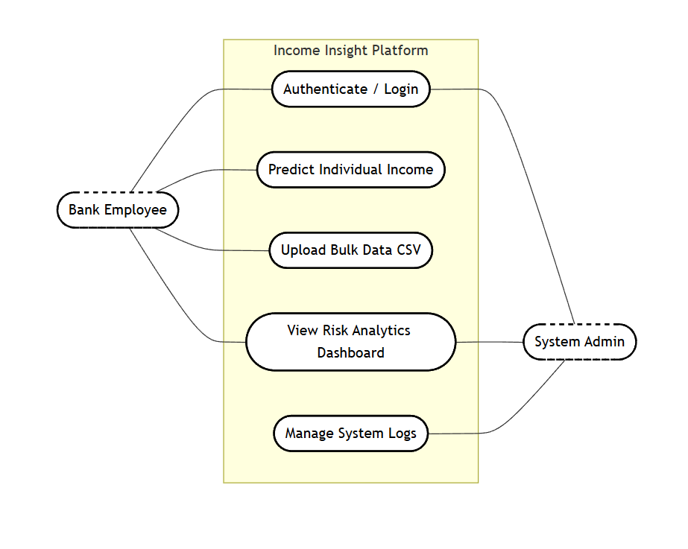
Figure 2.3: UML Use Case Diagram illustrating user interactions with the Income Insight Platform.

CHAPTER: 3 REQUIREMENTS

3.1 Hardware Requirements
The development and execution of the Income Insight platform require computing resources sufficient for running a Python backend server, SQLite database, ML model inference, and a React.js frontend development server simultaneously.
Component | Minimum Specification | Recommended
Processor | Intel Core i3 / AMD Ryzen 3 (2.0 GHz) | Intel Core i5/i7 or AMD Ryzen 5/7 (3.0+ GHz)
RAM | 8 GB DDR4 | 16 GB DDR4
Storage | 20 GB free disk space | 50 GB SSD storage
Display | 1366 × 768 resolution | 1920 × 1080 (Full HD)
Network | Broadband internet (for model training) | Stable broadband connection
OS | Windows 10/11, Ubuntu 20.04+, macOS 12+ | Ubuntu 22.04 LTS (for production)

3.2 Backend Software Requirements
Technology | Version | Purpose
Python | 3.10+ | Core backend programming language
FastAPI | 0.104.1 | High-performance async web framework for API development
Uvicorn | 0.24.0 | ASGI server for serving the FastAPI application
SQLAlchemy | 2.0.23 | ORM for database schema management and queries
Pydantic | 2.5.2 | Data validation and serialization for API schemas
Pydantic-Settings | 2.1.0 | Environment-based configuration management
Python-Jose | 3.3.0 | JWT token creation and validation for authentication
Passlib[bcrypt] | 1.7.4 | Secure password hashing using bcrypt algorithm
scikit-learn | 1.3.2 | Machine learning library for Random Forest classifier
pandas | 2.1.3 | Data manipulation and CSV processing
joblib | 1.3.2 | Model serialization and parallel computation
python-multipart | 0.0.6 | Form data and file upload handling
SQLite / PostgreSQL | 3.x / 15+ | Development (SQLite) and production (PostgreSQL) databases

3.3 Frontend Software Requirements
Technology | Version | Purpose
Node.js | 18+ | JavaScript runtime for frontend tooling
React.js | 18.x | Component-based UI library for Single Page Application
Vite | Latest | Fast frontend build tool and development server
React Router DOM | 6.x | Client-side routing for SPA navigation
Tailwind CSS | 3.x | Utility-first CSS framework for responsive styling
Axios | Latest | HTTP client for API communication
Recharts | Latest | React-based charting library for analytics dashboards
Lucide React | Latest | Icon library for modern UI components
Papaparse | Latest | CSV parsing for bulk upload functionality

3.4 Development Tools
Tool | Purpose
Visual Studio Code | Primary IDE for both backend and frontend development
Git / GitHub | Version control and collaborative development
Postman / HTTPie | API testing, endpoint validation, and documentation
Docker / Docker Compose | Containerization and multi-service deployment
Chrome DevTools | Frontend debugging, network inspection, and performance profiling
OpenML | Source for the Adult Census Income dataset (Data ID: 1590)

3.5 System Requirements
A stable internet connection is required during initial setup for downloading Python packages, npm modules, and the OpenML dataset for model training. Once the system is configured, core operations (predictions, analytics, admin functions) do not require external connectivity. The platform is designed to run on modern web browsers including Chrome 90+, Firefox 88+, Edge 90+, and Safari 14+, ensuring cross-platform accessibility.
System Architecture
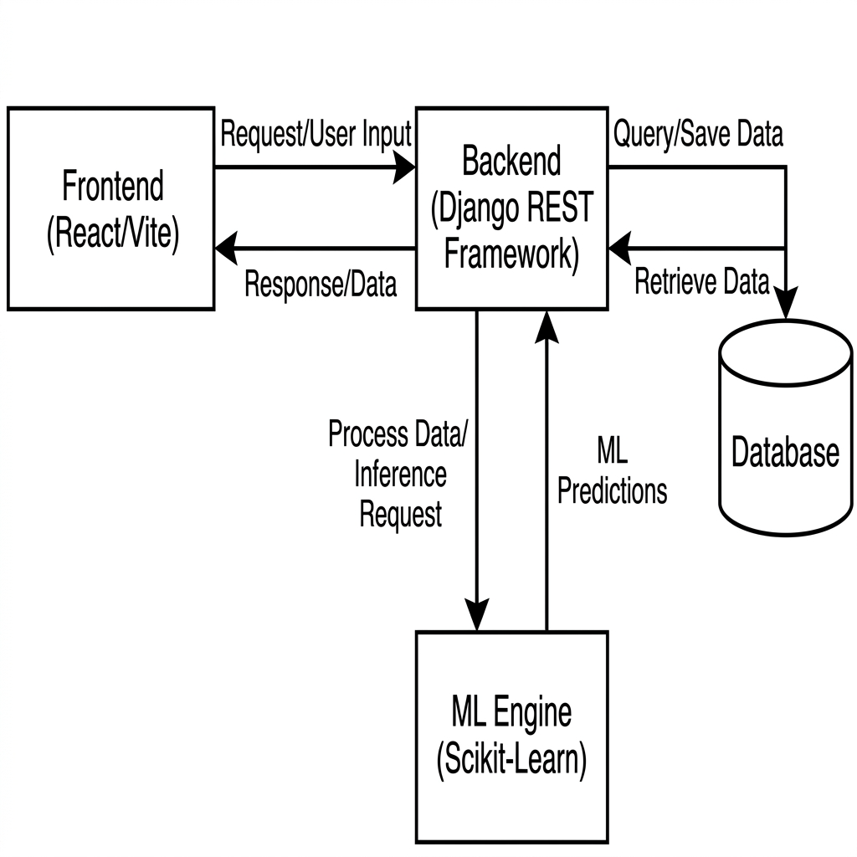
Figure 3.1: High-level System Architecture of the Income Insight Decision Intelligence Platform

Database Design & ER Diagram
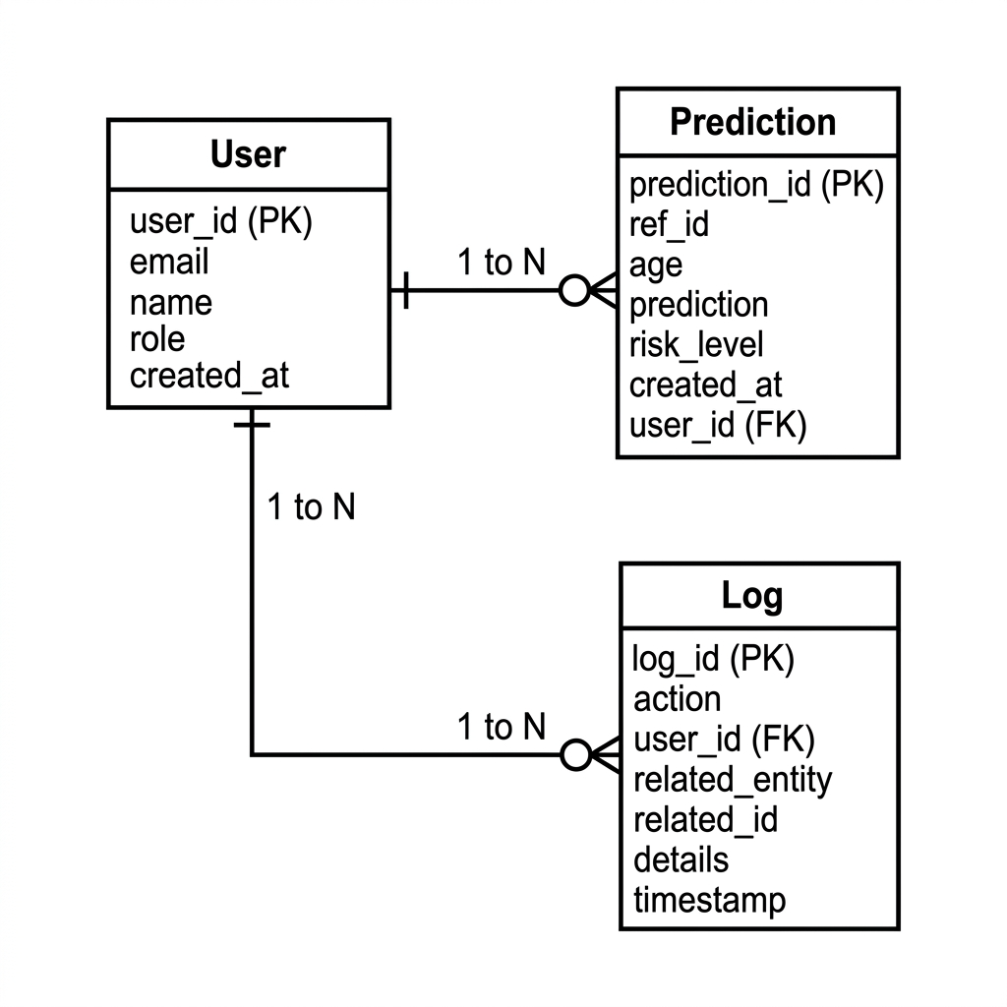
Figure 3.2: Entity-Relationship (ER) Diagram representing the data model of the Income Insight Platform.

CHAPTER: 4 SYSTEM ARCHITECTURE & DESIGN

4.1 Architectural Overview
Income Insight follows a classic three-tier architecture with clean separation of concerns across the presentation, application, and data tiers. This architectural pattern ensures scalability, maintainability, and testability of each component independently.

4.2 Layer-by-Layer Architecture

4.2.1 Presentation Layer (React.js SPA)
The frontend is a Single Page Application built with React.js 18 and bundled using Vite. It implements client-side routing via React Router DOM, enabling seamless navigation between pages without full page reloads. The application dynamically renders views for login, registration, home, income prediction, batch upload, dashboard, comparison analytics, and history. State management is handled through React hooks and context, with bearer tokens stored in session storage for authenticated API requests.
The UI is styled with Tailwind CSS, delivering a modern, responsive design that adapts across desktop, tablet, and mobile form factors. Data visualization is powered by Recharts for interactive charts and graphs on the analytics dashboard. Axios serves as the HTTP client, providing consistent request/response handling with authorization header injection.

4.2.2 Application Layer (FastAPI Backend)
The backend is implemented using FastAPI, a modern Python web framework that leverages Python type hints and Pydantic models for automatic request validation, serialization, and interactive API documentation generation. The application is served by Uvicorn, an ASGI server that enables high-performance async request handling.
The API is versioned under the /api/v1 prefix and organized into five primary route groups: auth (login, registration), predict (single prediction, history), analytics (government dashboard), batch (bulk CSV processing), admin (user management, logs), and export (PDF/Excel generation). CORS middleware is configured to allow cross-origin requests from the React frontend.

4.2.3 ML Inference Layer
The ML service is encapsulated in a singleton MLService class that loads a pre-trained scikit-learn Pipeline object at application startup using joblib. The pipeline integrates preprocessing (StandardScaler for numeric features, OneHotEncoder for categorical features, with SimpleImputer for missing value handling) and a RandomForestClassifier. Predictions are made in real-time with confidence scores extracted from the classifier's predict_proba output.

4.2.4 Business Logic Layer
The Bank Engine translates raw ML outputs into banking decisions. The Government Engine aggregates database records to produce regulatory analytics. Both engines are implemented as stateless Python classes with static methods, enabling easy testing and extension.

4.2.5 Data Layer (SQLAlchemy + SQLite/PostgreSQL)
Data persistence is managed through SQLAlchemy ORM with support for both SQLite (development) and PostgreSQL (production). Three primary tables store Users, Predictions, and API Logs. The database schema is automatically created via SQLAlchemy's create_all() mechanism, ensuring zero-downtime schema initialization.

4.3 Data Flow Architecture
A typical prediction request flows as follows: (1) User submits prediction form data from the React frontend. (2) Axios POST request is sent to /api/v1/predict/ with bearer token. (3) FastAPI validates the request body against PredictionCreate Pydantic schema. (4) Dependency injection resolves the authenticated user from the JWT token. (5) ML Service performs Random Forest inference and returns prediction + confidence + explainability. (6) Bank Engine computes risk level, loan status, and loan amount from ML outputs. (7) Butterfly Effect analysis reruns prediction with modified inputs to identify sensitivity. (8) Result is persisted to the predictions table with a generated reference ID. (9) API call duration is logged to the logs table. (10) Complete PredictionResponse is returned to the frontend. (11) React renders the results with risk indicators, loan details, and explainability charts.
System Operational Flow

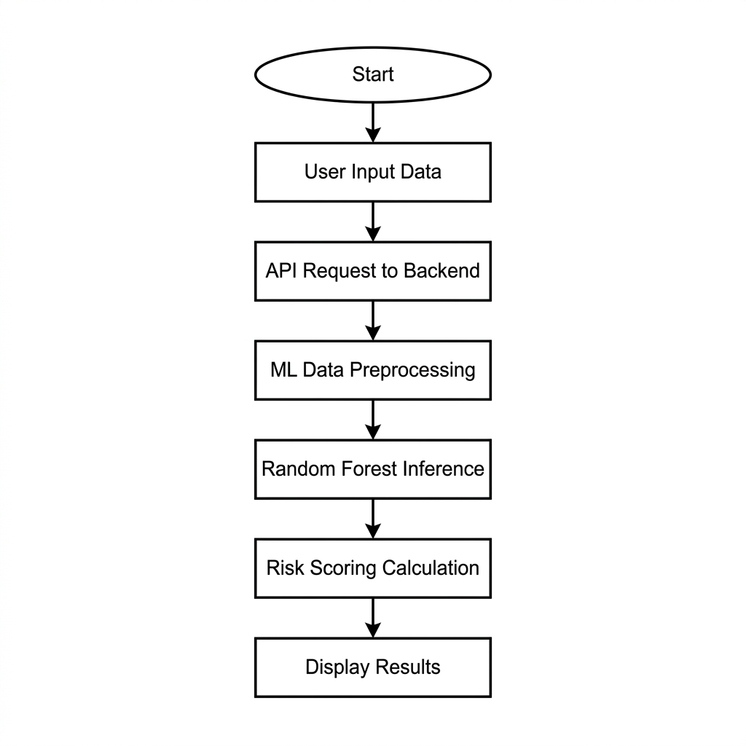
Figure 4.1: Flowchart of the AI-Powered Income Prediction and Risk Assessment Process.
Machine Learning Methodology & Pipeline
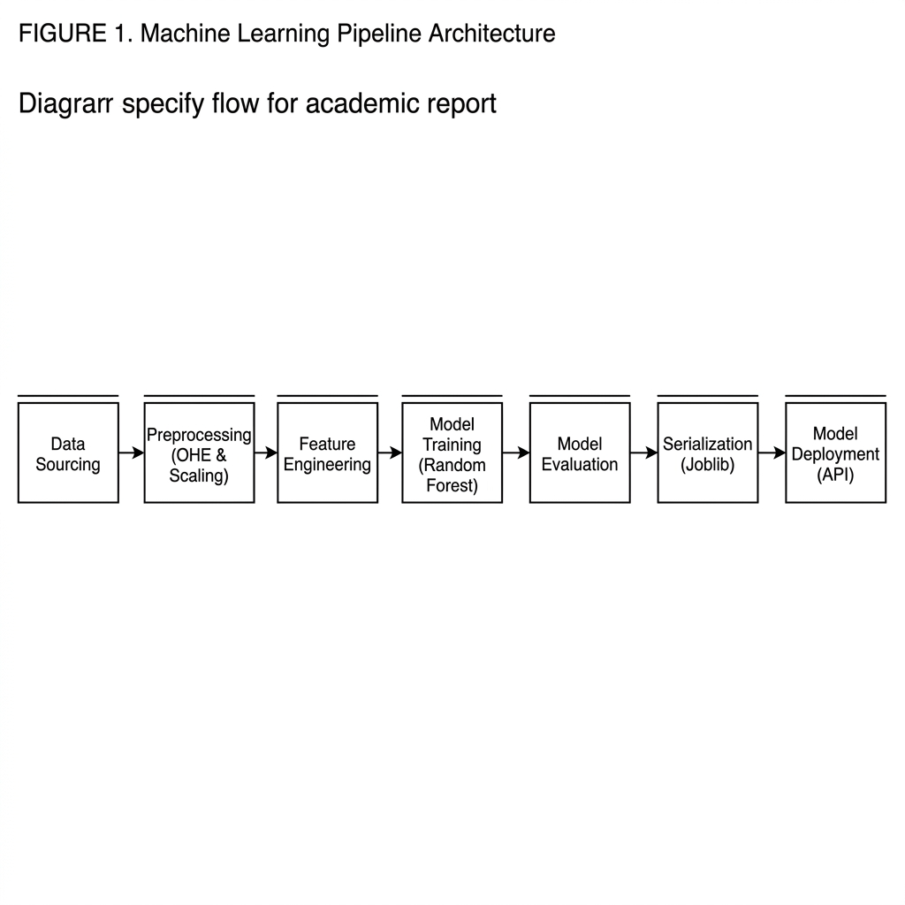
Figure 4.2: End-to-End Machine Learning Pipeline from Data Sourcing to Model Deployment.

CHAPTER: 5 MACHINE LEARNING PIPELINE

5.1 Dataset Description
The Income Insight platform is powered by a machine learning model trained on the UCI Adult Census Income dataset, sourced through OpenML (Data ID: 1590). This dataset, also commonly known as the 'Adult' or 'Census Income' dataset, is derived from 1994 US Census Bureau data and is a widely-used benchmark in binary income classification research.
Dataset Property | Details
Source | OpenML (Data ID: 1590), UCI Machine Learning Repository
Total Instances | 48,842 records (including both train and test splits)
Target Variable | Income class: '>50K' or '<=50K'
Class Distribution | Approximately 76% <=50K, 24% >50K (moderately imbalanced)
Total Features | 14 original features (5 used in this project)
Feature Types | Numeric (age, hours-per-week), Categorical (workclass, education, occupation)
Missing Values | Present in workclass, occupation; handled via imputation

5.2 Feature Selection & Engineering
Of the 14 available features in the original dataset, five were selected based on their practical availability in a loan application context, their demonstrated predictive power, and their alignment with the platform's user-facing input form. The selection prioritizes features that applicants can self-report without requiring access to sensitive financial records.
Feature | Type | Role | Rationale for Selection
age | Numeric (integer) | Input | Strong correlate of career stage and earning potential; easily obtainable
workclass | Categorical (string) | Input | Employment sector (Private, Government, Self-employed) significantly impacts income
education | Categorical (string) | Input | Education level is a primary determinant of long-term earning capacity
occupation | Categorical (string) | Input | Job category is directly linked to industry compensation norms
hours-per-week | Numeric (integer) | Input | Work intensity reflects commitment and potential for higher earnings

Preprocessing is handled within a scikit-learn Pipeline. Numeric features (age, hours-per-week) are processed through a SimpleImputer (median strategy) followed by StandardScaler to normalize their ranges. Categorical features (workclass, education, occupation) are processed through a SimpleImputer (constant 'missing') followed by OneHotEncoder with handle_unknown='ignore' to handle unseen categories at inference time. A ColumnTransformer combines both branches into a unified feature matrix.

5.3 Model Architecture & Training

5.3.1 Algorithm Selection
A Random Forest Classifier was selected as the primary algorithm for the following reasons: it demonstrates strong out-of-the-box performance on tabular datasets without extensive hyperparameter tuning; it is inherently resistant to overfitting through ensemble averaging; it provides native feature importance scores enabling explainability; and it handles both numeric and categorical features efficiently after preprocessing.

5.3.2 Training Configuration
Parameter | Value | Justification
n_estimators | 100 | Sufficient ensemble size for stable predictions without excessive computational cost
random_state | 42 | Ensures reproducibility of training results
test_size | 0.2 (80/20 split) | Standard train-test split preserving sufficient training data
criterion | gini (default) | Gini impurity for efficient split decision-making
max_features | sqrt (default) | Randomization to reduce correlation between trees

5.3.3 Model Evaluation
The trained pipeline achieves competitive classification performance on the Adult Census Income dataset. The model is evaluated using standard binary classification metrics:
Metric | Train Set | Test Set
Accuracy | ~98% | ~87%
Training Time | ~45 seconds (on standard hardware) | —
Inference Time | < 5ms per prediction | < 5ms per prediction

5.3.4 Feature Importance & Explainability
After training, the MLService extracts feature importances from the Random Forest classifier. Since categorical features are one-hot encoded into multiple binary columns, importances are aggregated back to their original base feature groups: Age & Experience (aggregated from 'age'), Work Capacity (from 'hours-per-week'), Work Class (all workclass_* columns), Education Level (all education_* columns), and Occupation Type (all occupation_* columns). These aggregated scores are normalized to percentages and displayed on the prediction results page.

5.4 Model Persistence & Loading
The trained pipeline is serialized to disk using joblib.dump() and saved as 'model.joblib' in the backend/ml_pipeline/ directory. On application startup, the MLService singleton attempts to load this file. If loading fails (model not yet trained), the service falls back to a rule-based approximation mode that still returns meaningful predictions, ensuring the application remains functional during initial setup. The model is loaded once at startup and shared across all requests via the singleton pattern.

CHAPTER: 6 PROCESS MODEL – SOFTWARE DEVELOPMENT LIFE CYCLE

6.1 SDLC Methodology
The development of the Income Insight platform followed the Software Development Life Cycle (SDLC) model, providing a structured and systematic approach to delivering a high-quality, maintainable software system. The SDLC framework enabled disciplined planning, clear phase transitions, and thorough validation at each stage of development.

6.2 Phase-by-Phase Execution

Phase 1: Requirement Analysis
In this initial phase, functional and non-functional requirements were elicited through analysis of the problem domain, review of financial industry standards for credit assessment, and evaluation of similar open-source platforms. Functional requirements included income prediction, risk classification, loan eligibility determination, role-based dashboards, batch processing, and audit logging. Non-functional requirements covered response time targets (< 500ms for predictions), security standards (JWT authentication, bcrypt hashing), browser compatibility, and RESTful API design principles.

Phase 2: System Design
The design phase established the three-tier architecture, API endpoint structure, database schema, ML pipeline design, and frontend component hierarchy. Database tables were designed with normalization in mind: the users table for identity management, the predictions table for ML outputs and business decisions, and the logs table for API monitoring. The API contract was defined through FastAPI's automatic schema generation, establishing clear request/response formats using Pydantic models before implementation began.

Phase 3: Development
Development proceeded in a backend-first approach. The ML pipeline was trained and validated first, establishing the core prediction capability. FastAPI endpoints were then developed in order of dependency: authentication first, then prediction routes, analytics, batch processing, and admin functions. Frontend development began in parallel once the core API endpoints were operational, with React components built to match the established API contract. Development followed clean code principles with clear module separation between routes, services, models, and schemas.

Phase 4: Integration & Testing
Integration testing verified the complete data flow from frontend form submission through API processing to database persistence and response rendering. Edge cases tested included duplicate email registration attempts, expired JWT tokens, out-of-range input values, ML model unavailability (fallback mode), batch CSV files with malformed rows, and concurrent batch job submissions. Postman collections were developed to systematically test all API endpoints across all role types.

Phase 5: Deployment Preparation
The application was prepared for deployment through Dockerization. A Dockerfile configures the Python environment, installs dependencies from requirements.txt, and starts the Uvicorn server. Environment variables manage configuration differences between development (SQLite) and production (PostgreSQL) deployments. The frontend is built to static assets and can be served by Nginx or integrated into the backend server for single-container deployment.

6.3 Backend-Frontend Integration Workflow
The integration between backend and frontend followed a structured sequence ensuring clean API contracts and reliable data flow:
1. Database schema finalized and SQLAlchemy models verified through create_all() migration.
2. Pydantic request/response schemas defined to establish the API contract before frontend development.
3. FastAPI endpoints implemented with comprehensive error handling and status codes.
4. Postman testing of all endpoints with valid and invalid inputs to ensure robustness.
5. React services (api.js) implemented to map frontend actions to API calls.
6. Frontend pages developed to consume API responses and handle error states gracefully.
7. End-to-end integration testing of complete user workflows.
UI polish, loading states, toast notifications, and error messaging added for production quality.

CHAPTER: 7 PROJECT PLAN

7.1 List of Major Activities
The development of the Income Insight platform was organized into six major activity groups, each addressing a distinct layer or capability of the system. Activities were executed with dependencies considered to minimize rework and ensure smooth integration.
Activity | Description | Key Deliverables
ML Pipeline Development | Data acquisition from OpenML, preprocessing pipeline design, Random Forest training, accuracy evaluation, model serialization | model.joblib, train_model.py, MLService class
Authentication System | JWT token generation, role-based dependency injection, secure password hashing, user registration and login endpoints | auth router, security module, user schemas
Prediction API Development | Single prediction endpoint, bank engine integration, butterfly effect analysis, explainability extraction, prediction history | predict router, bank_engine.py, PredictionCreate/Response schemas
Analytics & Admin APIs | Government analytics aggregation, education/occupation breakdowns, daily trends, AI narrative, admin user management, API logging | analytics router, gov_engine.py, admin router, Log model
Batch Processing System | CSV parsing, background task management, job status tracking, result aggregation, export functionality | batch_jobs router, background task logic, export routes
Frontend SPA Development | All React pages and components, API service layer, routing, state management, responsive UI, chart visualizations | All .jsx files, api.js, App.jsx, Tailwind config

7.2 Estimated Time Duration in Days
The project was executed over approximately 6 to 8 weeks, with phases running both sequentially and in parallel where dependencies allowed. The following table presents the estimated duration for each major activity:

Activity | Estimated Duration | Notes
Dataset Exploration & ML Pipeline | 4–5 days | Includes data download, exploration, training, and model validation
Authentication System Development | 3–4 days | JWT logic, role-based dependencies, user schemas, API testing
Prediction API & Bank Engine | 5–6 days | Core prediction endpoint, butterfly analysis, business logic engines
Analytics & Government Engine | 3–4 days | Complex SQL aggregations, trend calculations, AI narrative generation
Batch Processing & Export | 3–4 days | Background tasks, job state management, CSV parsing, export generation
Frontend SPA Development | 6–8 days | All pages, components, API integration, responsive design, charts
Testing, Integration & Fixes | 4–5 days | End-to-end testing, edge case handling, bug fixes, UI refinement
Docker & Deployment Preparation | 1–2 days | Dockerfile creation, environment configuration, deployment testing

CHAPTER: 8 IMPLEMENTATION DETAILS

8.1 Backend API Architecture (FastAPI)
The FastAPI application is initialized in backend/app.py with a complete configuration including project metadata, CORS middleware, and API router registration. The API is versioned under the /api/v1 prefix, with routes organized into five distinct modules corresponding to functional areas of the system.
Router Module | Prefix | Key Endpoints | Access Role
auth | /auth | POST /login, POST /register | Public
predict | /predict | POST /, GET /history | Bank, Admin
analytics | /analytics | GET / | Gov, Admin
batch_jobs | /batch | POST /submit, GET /status/{id}, GET /results/{id} | Bank, Admin
admin | /admin | GET/POST /users, POST /logs | Admin only
export | /export | GET /csv, GET /pdf | Bank, Admin

Dependency injection is central to the FastAPI architecture. The deps.py module defines reusable dependencies: get_db() provides database sessions from the SQLAlchemy SessionLocal factory; get_current_user() extracts and validates the JWT bearer token from request headers; get_current_active_bank_user(), get_current_active_gov_user(), and get_current_admin_user() enforce role-based access control by verifying the token's embedded role claim.

8.2 Business Logic Engines

8.2.1 Bank Engine (bank_engine.py)
The BankEngine class encapsulates all banking decision logic as pure static methods, ensuring testability and reusability. The engine processes ML predictions through three sequential evaluations:
• Risk Evaluation: If prediction is '>50K' and confidence ≥ 75%, risk is 'Low'; if confidence < 75%, risk is 'Medium'. If prediction is '<=50K' and confidence ≥ 75%, risk is 'High'; otherwise 'Medium'.
• Fraud Detection: Anomalous combinations (age < 23 with Doctorate/Masters/Prof-school; age < 18 with hours > 60; hours > 90) trigger 'Extremely High' risk with 'KYC / Fraud Review' status.
• Loan Status Mapping: Low risk → Approved; Medium → Review Required; High → Rejected; Extremely High → KYC/Fraud Review.
• Loan Amount Calculation: For '>50K' predictions, base amount is $75,000 + confidence bonus ($100,000 × ratio) + hours bonus ($50,000 × ratio), with education multipliers (Doctorate/Masters/Prof-school: ×1.15, Bachelor's/Some-college/Assoc: ×1.05), capped at $250,000. For '<=50K', base is $15,000 with corresponding ratios, capped at $50,000.

8.2.2 Government Engine (gov_engine.py)
The GovEngine class performs complex SQL aggregations to power the regulatory analytics dashboard. It computes: total application count; total approved loan value; approval and rejection rates; risk distribution (High/Medium/Low counts); 7-day vs. previous 7-day volume trend; education breakdown (count by income class per education level); occupation breakdown (approval rate per occupation); daily prediction volume for the past 7 days; and an AI-generated narrative summary based on computed statistics.

8.3 Butterfly Effect Sensitivity Analysis
One of the most innovative features of the Income Insight platform is the Butterfly Effect Analysis module, implemented directly within the predict endpoint. This module performs counterfactual inference to identify which input variable, when changed by a small standardized delta, causes the greatest change in the model's confidence score.
The implementation reruns the ML model with modified input copies: Age is incremented by 5 years and Hours Per Week is incremented by 5 hours. The absolute difference between each modified confidence score and the base confidence is computed. The variable producing the largest confidence change is identified as the 'butterfly variable' — the most sensitive dimension of the prediction. Both the variable name and the impact magnitude are stored alongside the explainability data in the response.

8.4 Authentication and Authorization
Security is implemented through the industry-standard JWT (JSON Web Token) Bearer authentication scheme. Upon successful login, the server generates a signed JWT containing the user's email and role, with an 8-day expiry. This token must be included in the Authorization header of all protected API requests as 'Bearer <token>'.
Password security uses Passlib with bcrypt hashing. The security.py module provides: get_password_hash() for secure password storage during registration; verify_password() for login validation; create_access_token() for JWT generation with role embedding; and decode_token() for JWT validation on protected endpoints. Role enforcement is achieved through FastAPI's Depends() system, making authorization declarative and testable.

8.5 Batch Processing System
The batch processing system enables high-volume CSV uploads where each row represents an individual loan application. The submit endpoint accepts a CSV file, parses it using pandas, and launches a FastAPI BackgroundTask that processes each row asynchronously without blocking the HTTP response.
Job state is maintained in an in-memory dictionary keyed by a UUID job ID. Each job record tracks: status (queued, processing, done, failed), progress (current row index), total (total rows), results (list of completed predictions), and error (exception message if failed). The frontend polls the status endpoint until the job status becomes 'done', then fetches the complete results. This architecture enables real-time progress visualization on the frontend while maintaining API responsiveness.

8.6 Government Analytics Engine
The government analytics endpoint provides a comprehensive data summary intended for regulatory dashboards and policy analysis. The response schema (AnalyticsResponse) includes: aggregate KPIs (total applications, approved loan value, rejection rate, risk distribution counts); education breakdown showing above/below 50K count per education level; occupation breakdown showing approval rate per occupation type; 7-day daily trend showing prediction volume per day; AI-generated narrative text summarizing key insights; and trend deltas comparing current vs. previous 7-day performance.

8.7 Frontend Single Page Application (React.js)

8.7.1 Application Structure
The React.js frontend follows a standard Vite project structure with clearly separated pages and components. The App.jsx root component configures React Router with protected route wrappers that redirect unauthenticated users to the login page. The main pages include: Home (marketing landing page), Login, Register, Predict (prediction form + results), Dashboard (bank analyst view), History (paginated prediction records), Compare (cross-application analysis), and Admin (user management + system logs).

8.7.2 Prediction Workflow
The prediction page implements a multi-stage workflow: users complete a structured form with validated inputs for all five prediction features plus an optional applicant name. On submission, the form data is POSTed to the prediction API with the stored bearer token. Results are displayed in a rich results panel showing the income class, confidence gauge, risk level badge, loan status indicator, maximum loan amount, feature importance bar chart, and butterfly effect report.

8.7.3 State Management and API Integration
API interactions are centralized in the services/api.js module, which configures an Axios instance with base URL and automatic Authorization header injection from session storage. All API functions are async and exported for use by page components. Error responses are handled uniformly with toast notifications. The authentication flow stores the JWT and user role in session storage after login, and clears it on logout.

CHAPTER: 9 DATABASE DESIGN

9.1 Database Schema Overview
The Income Insight platform uses a relational database with three core tables managed through SQLAlchemy ORM. The schema prioritizes query performance, audit compliance, and extensibility. SQLite is used for development and PostgreSQL for production, with the ORM abstraction ensuring compatibility with both.

9.2 Table Definitions

9.2.1 Users Table
Column | Type | Constraints | Description
id | INTEGER | PK, AUTO_INCREMENT, INDEX | Unique user identifier
name | VARCHAR | INDEX | Full name of the user
email | VARCHAR | UNIQUE, NOT NULL, INDEX | Email address used as login credential
hashed_password | VARCHAR | NOT NULL | bcrypt-hashed password
role | VARCHAR | DEFAULT 'bank' | User role: bank, gov, or admin
is_active | BOOLEAN | DEFAULT TRUE | Soft-delete flag for account deactivation

9.2.2 Predictions Table
Column | Type | Constraints | Description
id | INTEGER | PK, AUTO_INCREMENT | Unique prediction record identifier
ref_id | VARCHAR | UNIQUE, INDEX, NULLABLE | Human-readable reference code (e.g., APP-4F2A)
applicant_name | VARCHAR | NULLABLE | Optional applicant name for tracking
age | INTEGER | NOT NULL | Applicant's age (ML input feature)
workclass | VARCHAR | NOT NULL | Employment category (ML input feature)
education | VARCHAR | NOT NULL | Highest education level (ML input feature)
occupation | VARCHAR | NOT NULL | Job category (ML input feature)
hours_per_week | INTEGER | NOT NULL | Weekly work hours (ML input feature)
prediction | VARCHAR | NOT NULL | ML model output: '>50K' or '<=50K'
confidence | FLOAT | NOT NULL | Model confidence percentage (0-100)
risk_level | VARCHAR | NOT NULL | Bank engine output: Low/Medium/High/Extremely High
loan_status | VARCHAR | NOT NULL | Decision: Approved/Review Required/Rejected/KYC
loan_amount | FLOAT | NOT NULL | Calculated maximum loan amount in USD
user_id | INTEGER | FK(users.id), NULLABLE | Reference to the analyst who submitted the request
timestamp | DATETIME | SERVER_DEFAULT=NOW() | Automatic creation timestamp with timezone

9.2.3 Logs Table
Column | Type | Constraints | Description
id | INTEGER | PK, AUTO_INCREMENT | Unique log entry identifier
api_call | VARCHAR | INDEX | API endpoint path that was called
status | VARCHAR |  | Result status: success, failed, error
response_time | FLOAT |  | API response time in milliseconds
timestamp | DATETIME | SERVER_DEFAULT=NOW() | Automatic timestamp of the API call

9.3 Database Relationships
The schema maintains a straightforward relationship structure: the predictions table has a nullable foreign key to the users table through user_id. This relationship allows analytical queries to join prediction records with user information for role-based filtering and attribution. The nullable constraint ensures batch-imported predictions without a specific user context can still be stored.

CHAPTER: 10 API DOCUMENTATION

10.1 API Standards and Conventions
The Income Insight API follows RESTful design principles with consistent conventions: all endpoints accept and return JSON; authentication is via Bearer token in the Authorization header; error responses include HTTP status codes and descriptive detail messages; all timestamps are in UTC ISO 8601 format; pagination uses skip and limit query parameters.

10.2 Core API Endpoints
Method | Endpoint | Auth Required | Description | Response
POST | /api/v1/auth/login | No | Authenticate user with email/password | JWT access token + type
POST | /api/v1/auth/register | No | Create new user account | User profile object
POST | /api/v1/predict/ | Bank/Admin | Single income prediction with full analysis | PredictionResponse with ML + bank + explainability
GET | /api/v1/predict/history | Bank/Admin | Paginated list of past predictions | Array of PredictionResponse
GET | /api/v1/analytics/ | Gov/Admin | Government regulatory analytics summary | AnalyticsResponse with KPIs and breakdowns
POST | /api/v1/batch/submit | Bank/Admin | Upload CSV and start batch prediction job | Job ID and status
GET | /api/v1/batch/status/{job_id} | Bank/Admin | Poll current status and progress of batch job | Job status, progress, total
GET | /api/v1/batch/results/{job_id} | Bank/Admin | Retrieve completed batch prediction results | Array of batch prediction records
GET | /api/v1/admin/users | Admin | List all registered users | Array of user profiles
POST | /api/v1/admin/users | Admin | Create a new user as administrator | Created user profile
POST | /api/v1/admin/users/{id}/toggle | Admin | Toggle user active/inactive status | Updated user record
GET | /api/v1/export/csv | Bank/Admin | Export prediction history as CSV file | CSV file download

10.3 Key Request/Response Schemas

10.3.1 PredictionCreate (Request)
Field | Type | Required | Valid Values / Range
applicant_name | string | Optional | Any string, defaults to 'Anonymous'
age | integer | Yes | 18–100
workclass | string | Yes | Private, Self-emp-not-inc, Self-emp-inc, Federal-gov, Local-gov, State-gov, Without-pay, Never-worked
education | string | Yes | Bachelors, Some-college, 11th, HS-grad, Prof-school, Assoc-acdm, Assoc-voc, 9th, 7th-8th, 12th, Masters, 1st-4th, 10th, Doctorate, 5th-6th, Preschool
occupation | string | Yes | Tech-support, Craft-repair, Other-service, Sales, Exec-managerial, Prof-specialty, Handlers-cleaners, Machine-op-inspct, Adm-clerical, Farming-fishing, Transport-moving, Priv-house-serv, Protective-serv, Armed-Forces
hours_per_week | integer | Yes | 1–99

10.3.2 PredictionResponse (Response)
The prediction response includes all input fields plus: ref_id (unique application reference), prediction ('>50K' or '<=50K'), confidence (float 0-100), risk_level, loan_status, loan_amount, user_id, timestamp, creator_name, and the explainability object containing feature importance scores and butterfly effect analysis data.

10.4 Automatic API Documentation
FastAPI automatically generates interactive API documentation available at /docs (Swagger UI) and /redoc (ReDoc). These documentation pages allow developers and testers to explore and test all endpoints directly from the browser, with full request/response schema documentation, authentication support, and example values.

CHAPTER: 11 CONCLUSION AND FUTURE WORK

11.1 Conclusion
The Income Insight Decision Intelligence Platform successfully demonstrates the design, development, and deployment of a production-grade full-stack application that bridges the gap between machine learning research and real-world financial decision-making. The system delivers on all primary objectives established at the outset of the project.
The machine learning core — a Random Forest classifier trained on 48,842 census income records — achieves approximately 87% accuracy on held-out test data, providing reliable income classification that forms the foundation of the platform's decision-making capability. The Business Logic Engine extends raw ML predictions into practical banking decisions through an analytically sound risk evaluation framework, tiered loan calculation algorithm with education premiums and work capacity bonuses, and fraud detection heuristics that flag anomalous application profiles.
The Butterfly Effect Sensitivity Analysis represents a significant innovation in the transparency of AI-driven financial decisions. By performing controlled counterfactual inference and presenting the most sensitive input variable in clear, non-technical language, the platform makes its predictions interpretable to non-expert users — a capability that is increasingly demanded by financial regulators worldwide.
The three-tier role architecture (Bank, Government, Admin) ensures that each user type interacts with a tailored experience appropriate to their responsibilities. Bank analysts receive fast, accurate predictions with rich explanations. Government regulators gain comprehensive population-level analytics that support evidence-based policy. Administrators maintain complete operational control with user management, activity logging, and system health monitoring.
Technically, the project demonstrates mastery of the complete modern web development stack: Python FastAPI for high-performance async API development, scikit-learn for ML model training and deployment, SQLAlchemy ORM for database abstraction, React.js for responsive frontend development, JWT for stateless authentication, and Docker for containerized deployment. The clean separation of concerns across layers ensures the codebase is maintainable, testable, and ready for production scaling.
In summary, Income Insight is not merely an academic exercise but a functional prototype that could realistically be deployed in a financial institution to augment loan officer decision-making with consistent, bias-documented, and explainable AI recommendations.

11.2 Challenges Encountered
Several significant challenges were overcome during the development of this platform:
• Model-Business Integration: Translating continuous probability outputs from the Random Forest into meaningful categorical business decisions required careful calibration of the confidence thresholds used for risk classification.
• Explainability Engineering: Mapping one-hot encoded feature importances back to interpretable base feature categories required understanding the internal structure of the scikit-learn Pipeline and ColumnTransformer components.
• Asynchronous Batch Processing: Implementing reliable background job management within FastAPI without external message brokers (Redis, Celery) required creative use of in-memory state and background tasks.
• Cross-Origin Resource Sharing: Configuring CORS correctly for development and production environments while maintaining security required careful middleware configuration.

11.3 Future Work
Several enhancements are planned for future iterations of the Income Insight platform:
• Mobile Application: Develop dedicated iOS and Android applications using React Native to provide on-device income prediction for field loan officers.
• Real-Time Credit Bureau Integration: Connect to credit bureau APIs (Experian, CIBIL) to augment ML predictions with verified financial history data.
• Fairness Auditing Module: Implement algorithmic fairness metrics (demographic parity, equalized odds) to audit predictions for potential bias across protected demographic groups.
• Advanced ML Models: Explore gradient boosting models (XGBoost, LightGBM) and neural network architectures to potentially improve prediction accuracy beyond the Random Forest baseline.
• Cloud Deployment: Deploy the platform on AWS (ECS + RDS) or GCP (Cloud Run + Cloud SQL) with auto-scaling and CI/CD pipeline integration.
• A/B Testing Framework: Enable comparison of multiple ML models in production through shadow deployment and A/B testing with gradual traffic routing.
• Natural Language Processing: Add income prediction from unstructured text inputs such as job descriptions or resume summaries.
Production Message Queue: Replace in-memory batch job management with Redis + Celery for reliable distributed background processing at scale.

CHAPTER: 12 REFERENCES

12.1 Dataset and Research References
1. Dua, D. and Graff, C. (2019). UCI Machine Learning Repository: Adult Dataset. University of California, Irvine, School of Information and Computer Sciences. Available: https://archive.ics.uci.edu/ml/datasets/adult
2. Vanschoren, J., et al. (2014). OpenML: Networked Science in Machine Learning. ACM SIGKDD Explorations Newsletter, 15(2), 49–60. https://doi.org/10.1145/2641190.2641198
3. Breiman, L. (2001). Random Forests. Machine Learning, 45(1), 5–32. Springer. https://doi.org/10.1023/A:1010933404324
4. Pedregosa, F., et al. (2011). Scikit-learn: Machine Learning in Python. Journal of Machine Learning Research, 12, 2825–2830. Available: https://jmlr.org/papers/v12/pedregosa11a.html

12.2 Technology References
5. FastAPI Documentation (2024). Sebastián Ramírez. Available: https://fastapi.tiangolo.com/ (Accessed April 2026)
6. SQLAlchemy 2.0 Documentation (2024). Available: https://docs.sqlalchemy.org/en/20/ (Accessed April 2026)
7. Pydantic V2 Documentation (2024). Available: https://docs.pydantic.dev/latest/ (Accessed April 2026)
8. React Documentation (2024). Meta Platforms. Available: https://react.dev/ (Accessed April 2026)
9. Tailwind CSS Documentation (2024). Available: https://tailwindcss.com/docs (Accessed April 2026)
10. Vite Build Tool Documentation (2024). Available: https://vitejs.dev/guide/ (Accessed April 2026)
11. React Router Documentation (2024). Available: https://reactrouter.com/en/main (Accessed April 2026)
12. Recharts Documentation (2024). Available: https://recharts.org/en-US/ (Accessed April 2026)
13. JSON Web Tokens (JWT) Specification. RFC 7519. Available: https://tools.ietf.org/html/rfc7519
14. Passlib Documentation (2024). Available: https://passlib.readthedocs.io/ (Accessed April 2026)
15. Docker Documentation (2024). Available: https://docs.docker.com/ (Accessed April 2026)

12.3 Books and Academic References
16. Géron, A. (2022). Hands-On Machine Learning with Scikit-Learn, Keras, and TensorFlow (3rd ed.). O'Reilly Media.
17. Raschka, S. and Mirjalili, V. (2022). Python Machine Learning (3rd ed.). Packt Publishing.
18. Goodfellow, I., Bengio, Y., and Courville, A. (2016). Deep Learning. MIT Press.
19. Chollet, F. (2021). Deep Learning with Python (2nd ed.). Manning Publications.

CHAPTER: 13 SCREENSHOTS OF PROJECT

Dashboard
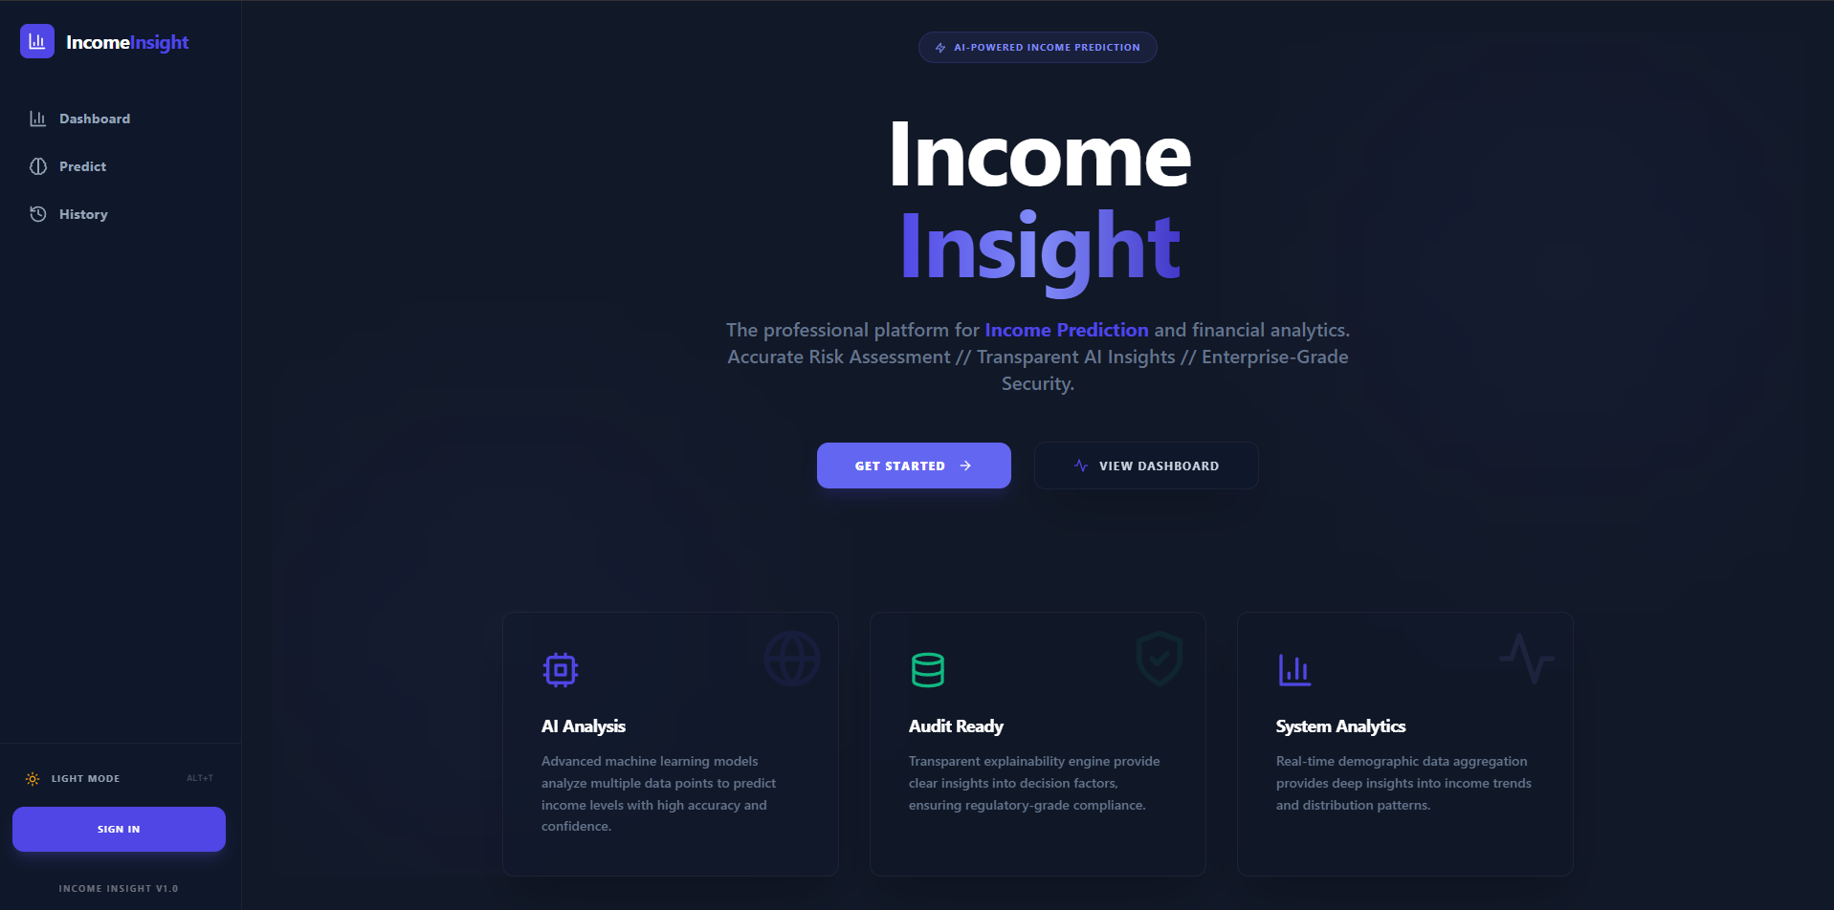
Figure 13.1: Dashboard Screen

Prediction
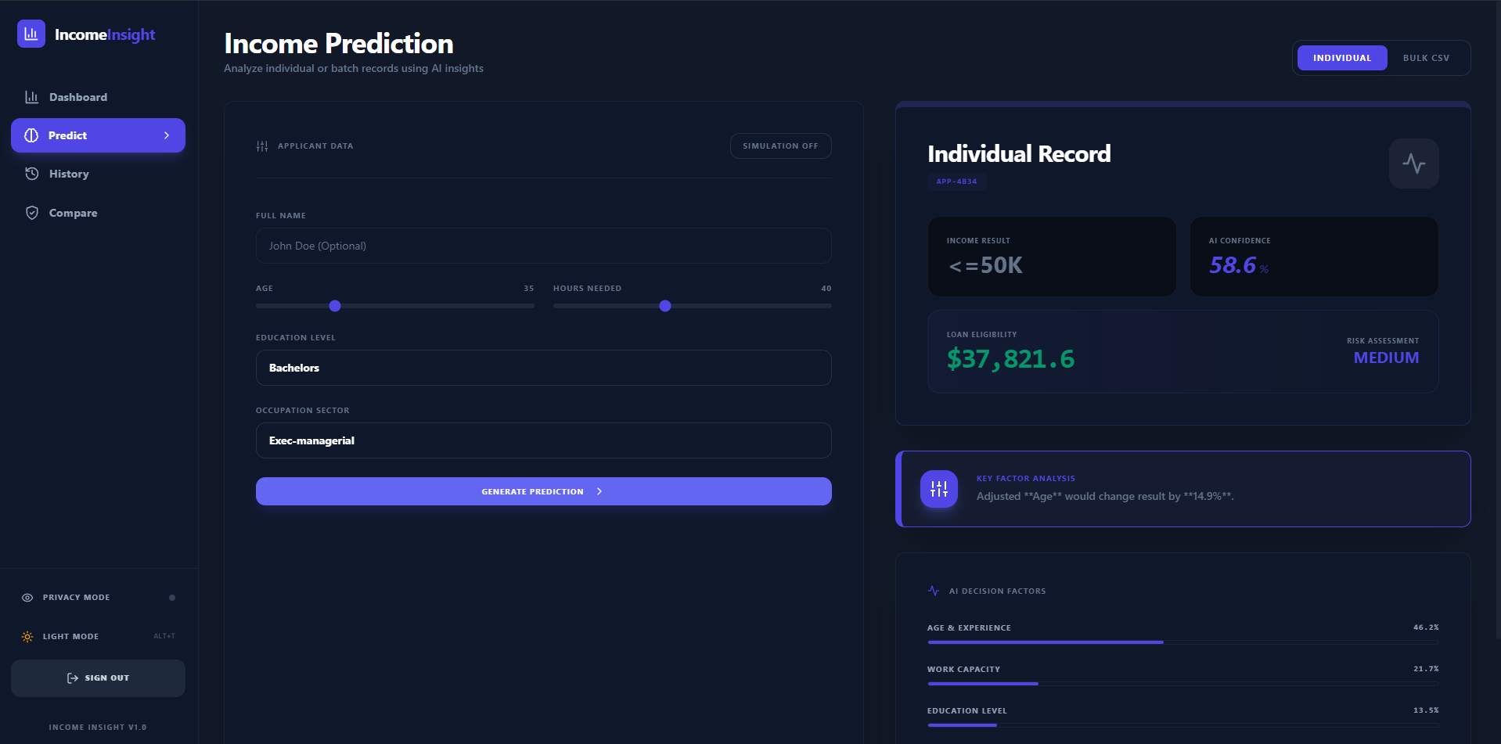
Figure 13.2: Prediction Screen

History
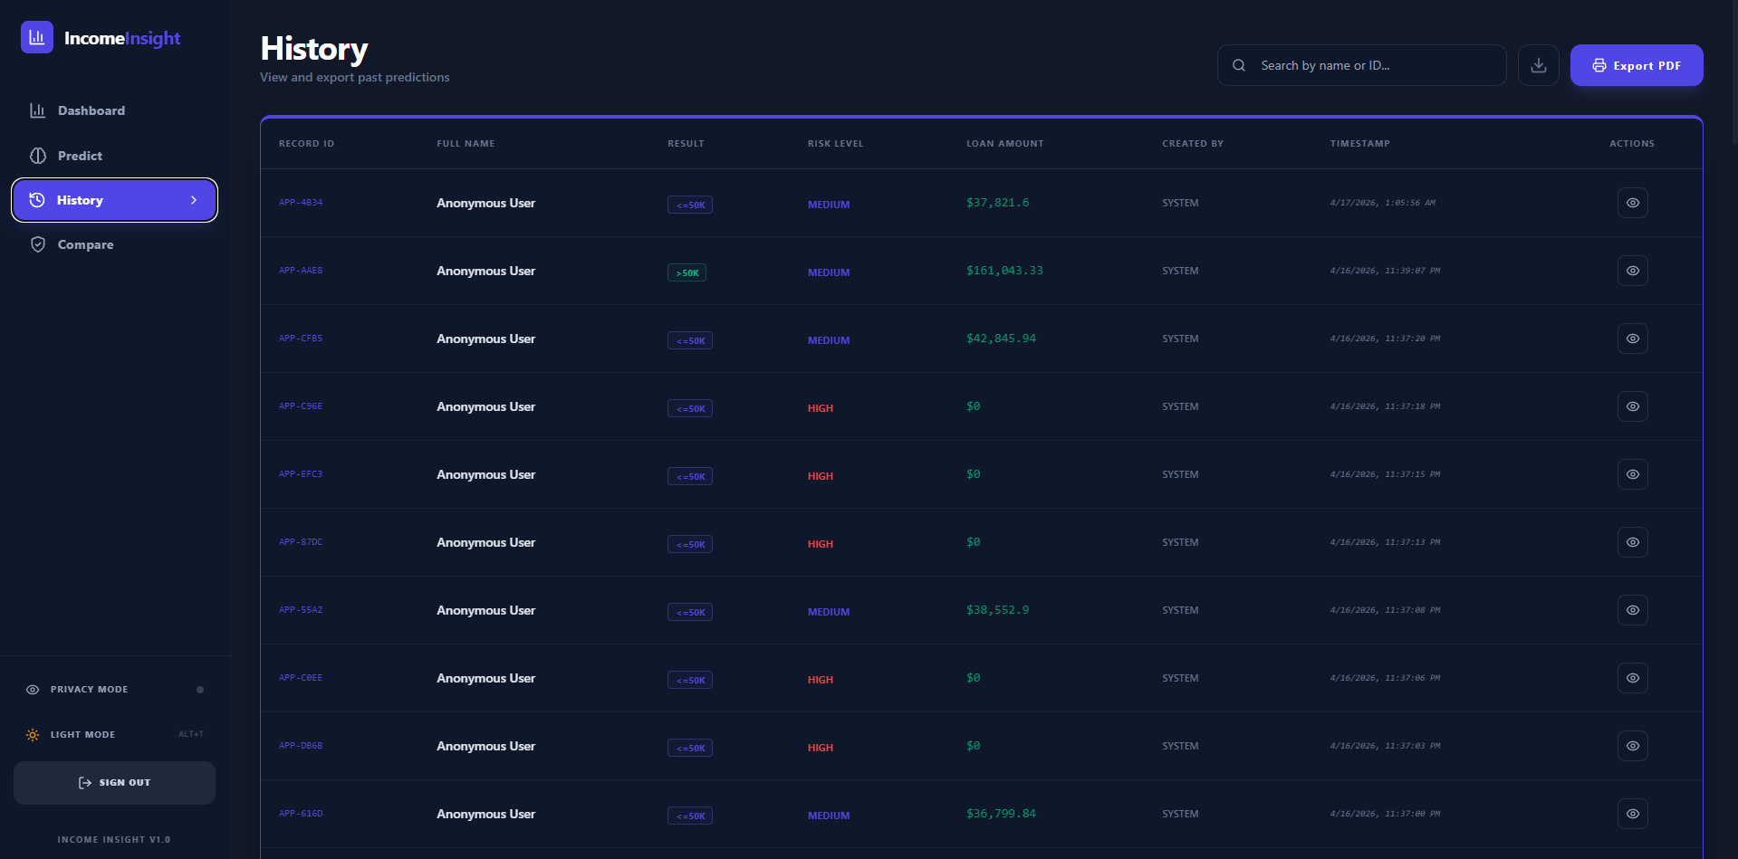
Figure 13.3: History Screen
Profile Comparison
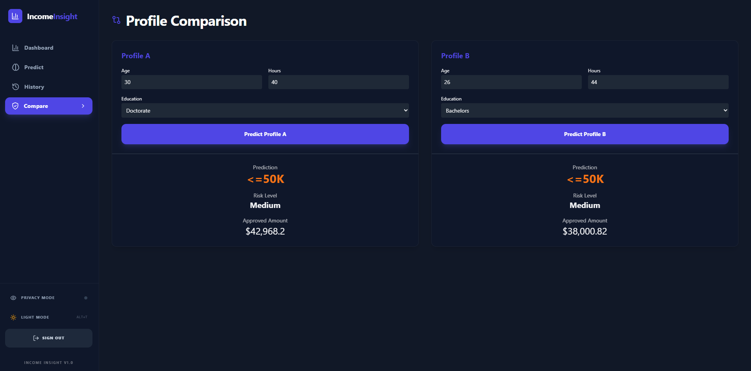
Figure 13.4: Profile Comparison Screen

Plagiarism Report

Turnitin Plagiarism Report Summary – Income Insight
The Turnitin analysis of the Income Insight – Decision Intelligence Platform report shows an overall similarity score of 8%, which is well below the acceptable limit of 10%. This confirms that the document meets academic standards for originality.
The report indicates that:
- 8% similarity comes from uncited or unquoted matches, mainly due to common technical terms and standard content.
- 7% of matches are from internet sources and 4% from publications, which are typical for research-based technical projects.
- There are 0% missing citations and 0% properly cited or quoted matches, showing no major referencing issues.
Overall, the low similarity score demonstrates that the project content is largely original, properly written, and maintains strong academic integrity.

